Experiment No. : 3

Title : Contactor Circuits

Date : 21/09/2021
Name : Shaunak Deshpande
Roll no : 39
Gr no : 11911180
Division : TY IC-C

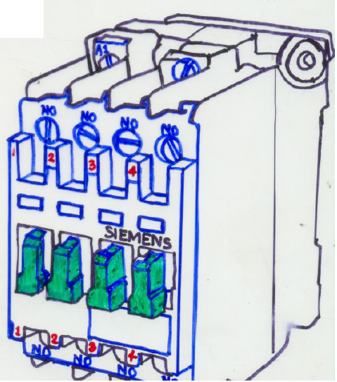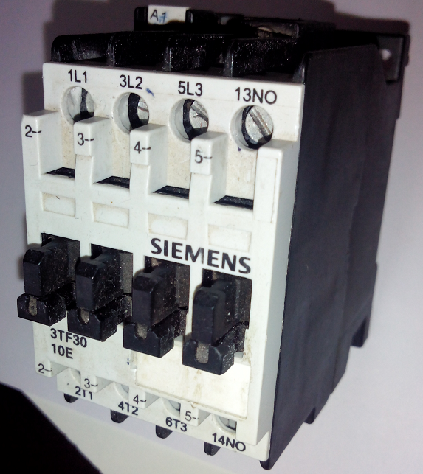

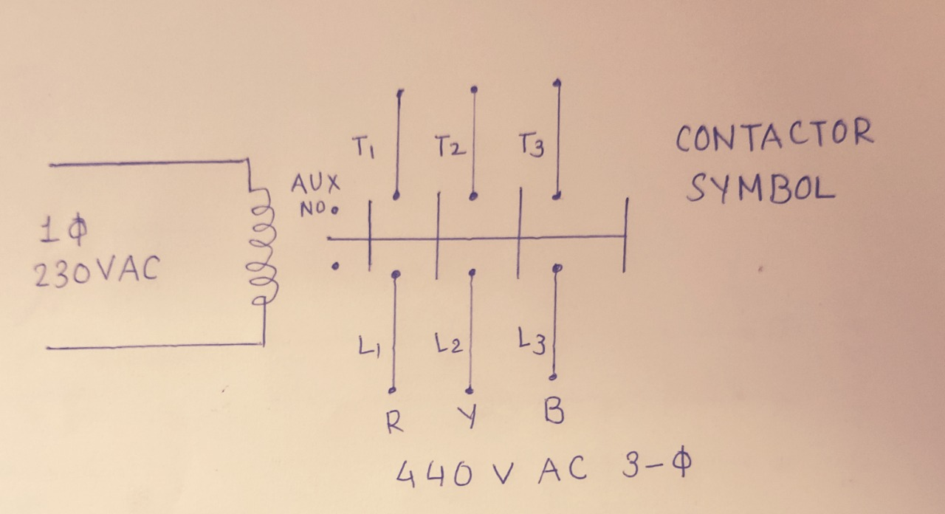
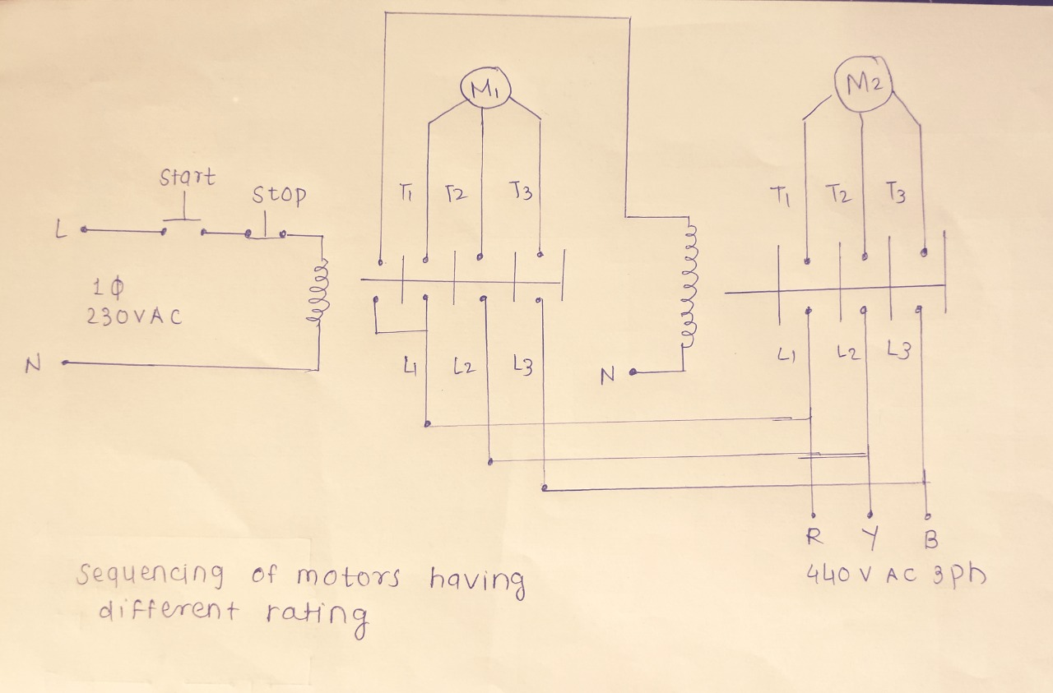
Figure 1.1 : Contactor construction and Symbol

Experiment No : 3

Contactors

Aim : Study of contactor and implementation of logic circuits for applications like latching, sequencing, interlocking and direction control of 3-phase AC motor.
Components required:

Sr. No. | Components | Short specifications | Quantity
01. | Contactor | With Auxiliary NO and NC contacts | 02
02. | Pushbuttons | Push-to-ON, NO, 230Vac, 5A | 01
02. | Pushbuttons | Push-to-OFF, NC, 230Vac, 5A | 01
03. | Lamps | 230 Vac, Green and Red colour | 02
04. | Motor | 3-phase | 01
05. | Power Supply | 230 Vac, 5A power chord | 03
06. | Digital Multimeter | For continuity test | 01
07. | Connecting wires | Multistrand / Patch cords | As required

Theory :
Introduction : The magnetic contactor is similar in operation to the electromechanical relay. Both have one feature in common, contact operate when coil is energized.
Generally relay is used to switch 1-phase, 230 Vac, 5 A or less, while contactor is used to switch 3-phase, 440Vac load without being damaged. Such loads include motors, lights capacitors, transformers and heaters.
The advantages of contactors over manually operated lever control equipment are:
- Small in size and easy to operate.
- Sequencing and interlocking can be implemented.
- Useful in repeated switching.
- Safety isolation from high voltage power line.
- Can be operated from remote pilot devices.
- Can be used with PLC.

Types of Contactors:
Contactors are classified according to its construction as:
a) Clapper type b) Bell crank type c) Vertical action type d) Horizontal action type

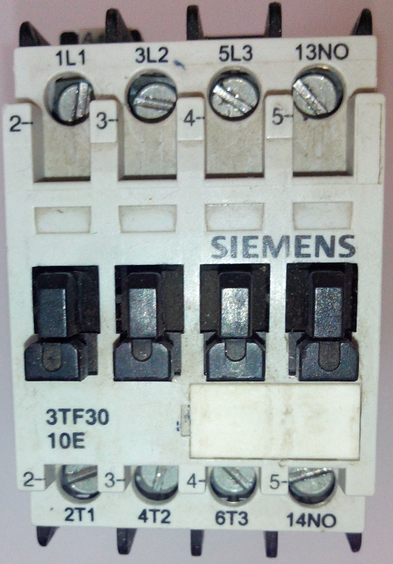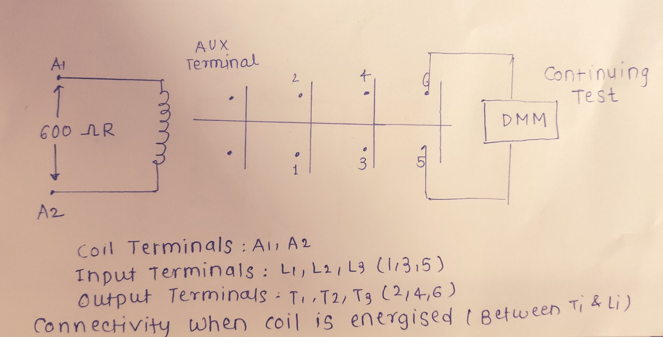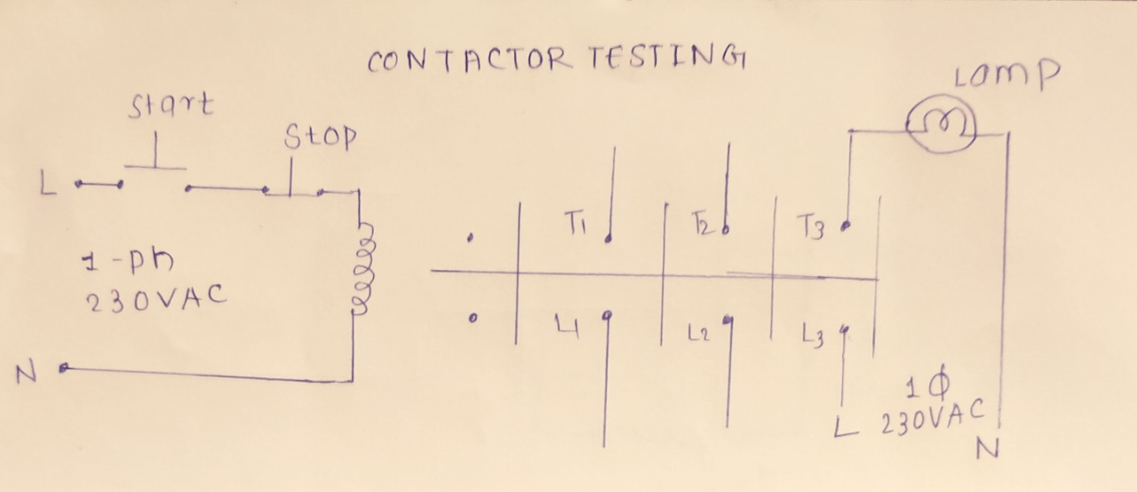

Figure 1.2 : Contactor Terminal Identification & Testing

Specification of contactors:
Protection/Enclosure | : Finger (IP-20)
Mounting | : Surface/DIN rail
Number of contacts | : Three (NO)
Auxiliary contacts | : Two ( NO and NC)
VI Rating | : AC: 45 A, 230 V, 20 HP  DC: 50 A, 230 V, 10 HP
Coil consumption | : 24 VA
In rush current | : 240 VA
Temperature | : -20 °C to +70 °C
Vibration/Shock | : 100 / 300 g
Electrical life | : 10^4 operations
Ton/Toff | : 20 msec
Implementation of Contactor Circuits:
Precaution : Great care must be taken while using 230 V AC power supply. Do not touch at any points in the power circuit to prevent electric shock because these are at high potential.
- Contactor Terminal Identification: Before connecting a contactor in a circuit, it is required to find its terminals. Contactor having eight terminals: Two coil terminals (A1 and A2), three contacts terminals (L1, L2 and L3) for input 3-phase power supply and three contacts terminals (T1, T2 and T3) for connecting 3-phase load. Operate contactor manually and check the continuity between input and output terminals using digital multimeter. See Figure 1.2.

- Testing of Contactor: In this section working of contactor is demonstrated. Connect Push-to-ON and Push-to-OFF switches in control circuit of contactor as shown in Figure 1.2. Use lamp in power circuit by connecting it to one of contact pair of the contactor. Give 230 Vac supply to control circuit and 230VAC supply to power circuit. When Push-to-ON switch (acts as a START) is pressed, then lamp turns on. When Push-to-OFF switch (acts as a STOP) is pressed, then lamp turns off. Thus a contactor is used to make a lamp on and off. Here it is required to hold Push-to-ON switch for continuous lamp on otherwise this switch become open and lamp turns off. This shows a need of latching the Push-to-ON pushbutton. Here for simplicity 230 Vac power supply is selected for both control and power circuits.
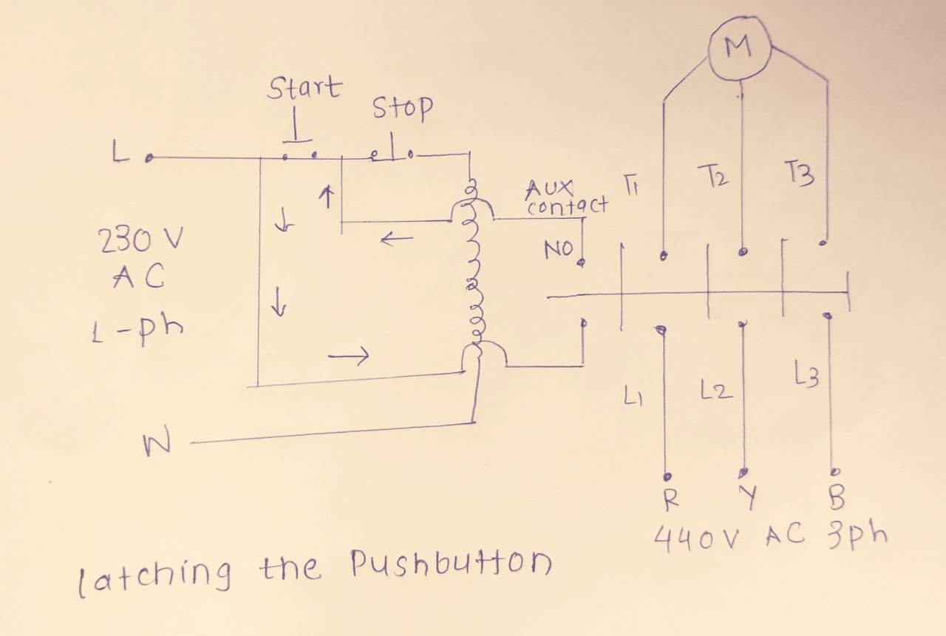
Figure 1.3 : Latching the Pushbutton
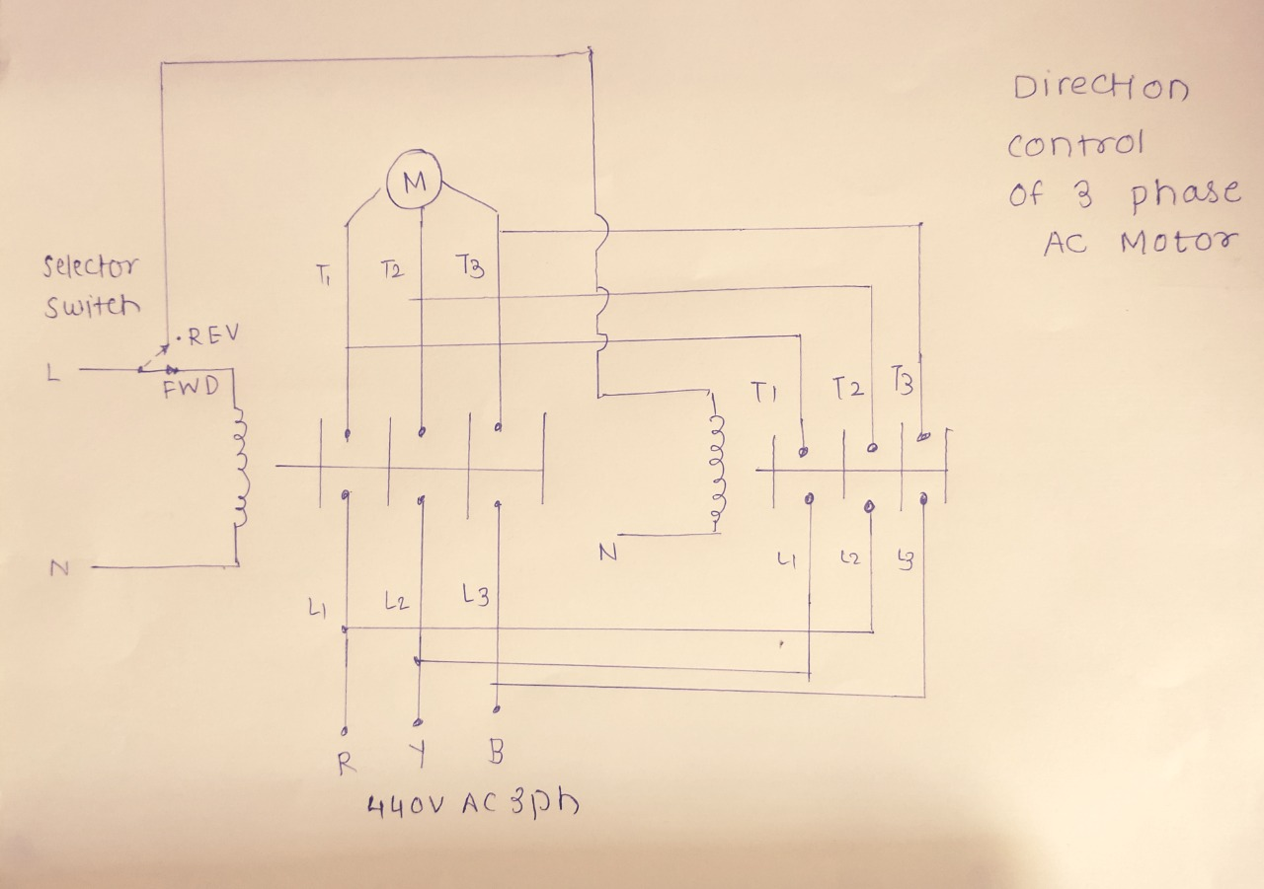
Figure 1.4: Sequencing of Lamps (actually motors having different rating)

- Latching the Pushbutton: To latch the pushbutton there is need of auxiliary NO contact of contactor. Connect Push-to-ON and Push-to-OFF switches in control circuit of contactor as shown in Figure 1.3. Use lamp in power circuit by connecting it to NO terminal of the contactor. Connect auxiliary NO contacts (13 and 14) available in contactor in parallel with Push-to-ON switch. Give 230VAC supply to control circuit and power circuit. When Push-to-ON switch (acts as a START) is pressed, then lamp turns on. There is no need to hold Push-to-ON switch for continuous lamp on. If you remove finger from START button, then circuit remain closed through these auxiliary NO contacts (13 and 14). When Push-to-OFF switch (acts as a STOP) is pressed, then lamp turns off.

- Sequencing of Lamps (actually 3-phase loads!): Sequencing of lamps means to make lamps ON one after. If there are two lamps and when first lamp is on, immediately or after some delay (if timer is used) second lamp is also on. If first lamp is off then immediately or after some delay (if timer is used) second lamp is also turn off.
In this section, two outputs (lamps) having same voltage and current rating is used and same circuit may be used for two outputs having different 3-phase power ratings.
For making two lamps ON in sequence (actually these are 3-phase motors!), two contactors are to be required. They should be energizing in sequence. Use only Push-to-ON switch (acts as a START) in control circuit of first contactor. Connect auxiliary NO contact of first contactor to coil of second contactor as shown in Figure 1.4. Give 230 Vac supply to control circuit and 230VAC supply to power circuit. When Push-to-ON switch is pressed, then both lamps turn on. When Push-to-ON switch is not pressed, then both lamps turn off. Thus an auxiliary NO contact is used for sequencing of lamps.
- Interlocking of Lamps (actually 3-phase loads!): Interlocking of lamps means to make lamps on alternately. If there are two lamps and when first lamp is on, immediately or after some delay (if timer is used) second lamp should be off. If first lamp is off then immediately or after some delay (if timer is used) second lamp should be turn on.
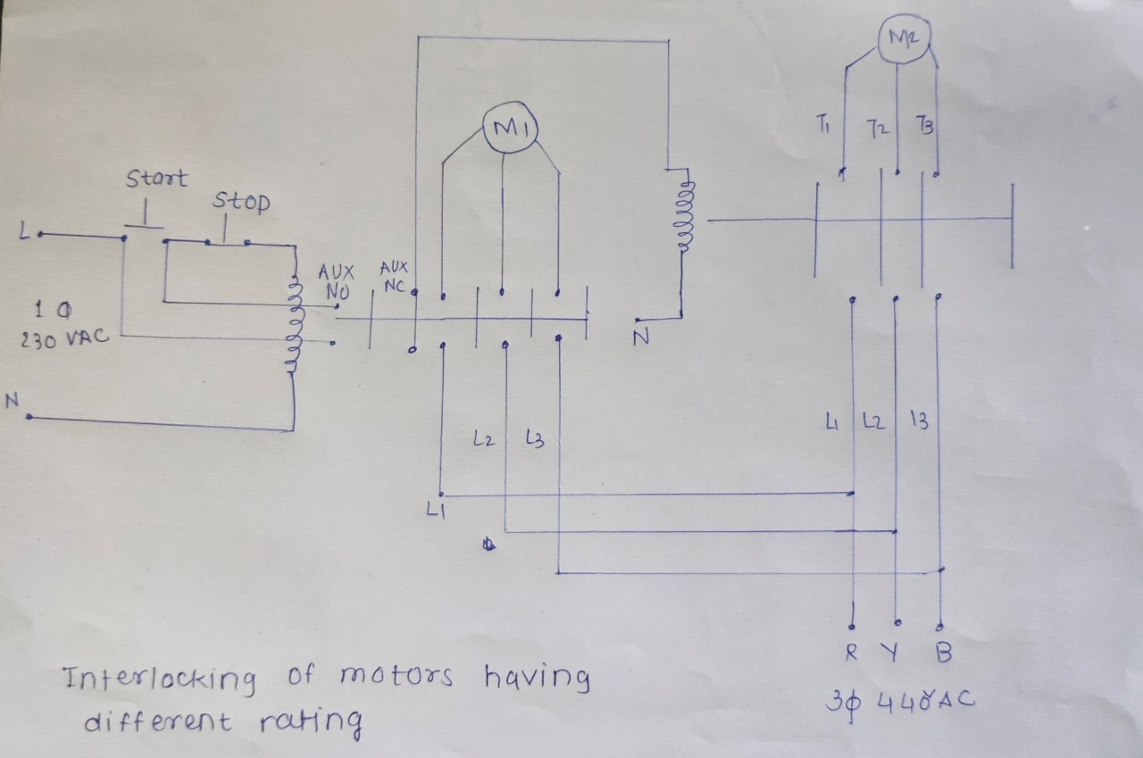
Figure 1.5: Interlocking of Lamps (actually motors having different rating)
Figure 1.6: Direction Control of 3-phase AC Motor

In this section, two outputs (lamps) having same voltage and current rating is used and same circuit may be used for two outputs having different 3-phase power ratings.
For making two lamps ON alternately (actually these are 3-phase motors!), two contactors are to be required. They should be energizing one at a time. Use only Push-to-ON switch (acts as a START) in control circuit of first contactor. Connect auxiliary NC contact of first contactor to coil of second contactor as shown in Figure 1.5. Give 230 Vac supply to control circuit and 230VAC supply to power circuit. When Push-to-ON switch is pressed, then first lamp is on and second lamp should be turn off. When Push-to-ON switch is not pressed, then first lamp is off and second lamp will be on. Thus an auxiliary NC contact is used for interlocking of lamps.
- Direction Control of 3-phase Motor: Direction of rotation of dc motor can be changed by interchanging any two phases out of three and keep on phase as it is. To interchange two phases, two contactors are to be required. They should be energizing one at a time. For this purpose you can use interlocking circuit or a selector switch. Here we use a selector switch to select direction of rotation of motor – Forward or Reverse.
Use selector switch in control circuit of first contactor. Connect Forward position terminal of selector switch to first contactor coil and Reverse position terminal to second contactor coil as shown in Figure 1.6. Connect power circuit of two contactors so that any two phases will be interchanged. Keep one phase as it is. Give 230 Vac supply to control circuit and 3-phase 440VAC supply to power circuit. When selector switch is on Forward position, first contactor coil gets energized and motor rotates in forward direction. When selector switch is on Reverse position, second contactor coil gets energized and motor rotates in reverse direction.

Conclusion:
- In order to implement Latch auxiliary NO contact of a Contactor is used.
- To implement Sequencing Circuit, auxiliary NO contact of first contactor is used to energize the coil of second contactor.
- To implement Interlocking Circuit, auxiliary NC contact of first contactor is used to de-energize the coil of second contactor.
- To change the direction of 3-phase motor, any two phases are interchanged with help of two contactors.

